Chapter 10, Solution 57.

Using Fig. 10.100, design a problem to help other students to better understand Thevenin and Norton equivalent circuits.

Although there are many ways to work this problem, this is an example based on the same kind of problem asked in the third edition.

Problem

Find the Thevenin and Norton equivalent circuits for the circuit shown in
Fig. 10.100.

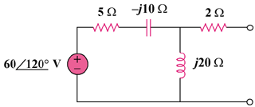

Figure 10.100

Solution

To find 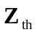, consider the circuit in Fig. (a).
Z_{th}
(a)
2 
-j10 
5 
j20 

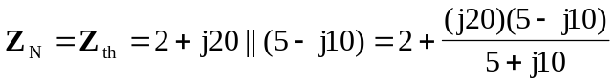
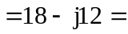 21.633-33.7 

To find 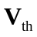, consider the circuit in Fig. (b).
(b)
2 
-j10 
5 
j20 
60120 V
+
−
+
V_{th}
−

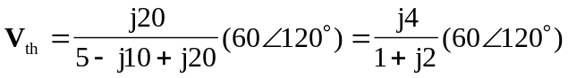
= 107.3146.56 V

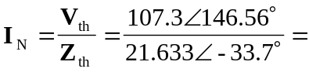 4.961-179.7 A

